Agenda Item 8a(4)
Quotes Received for new fencing around toddler play equipment

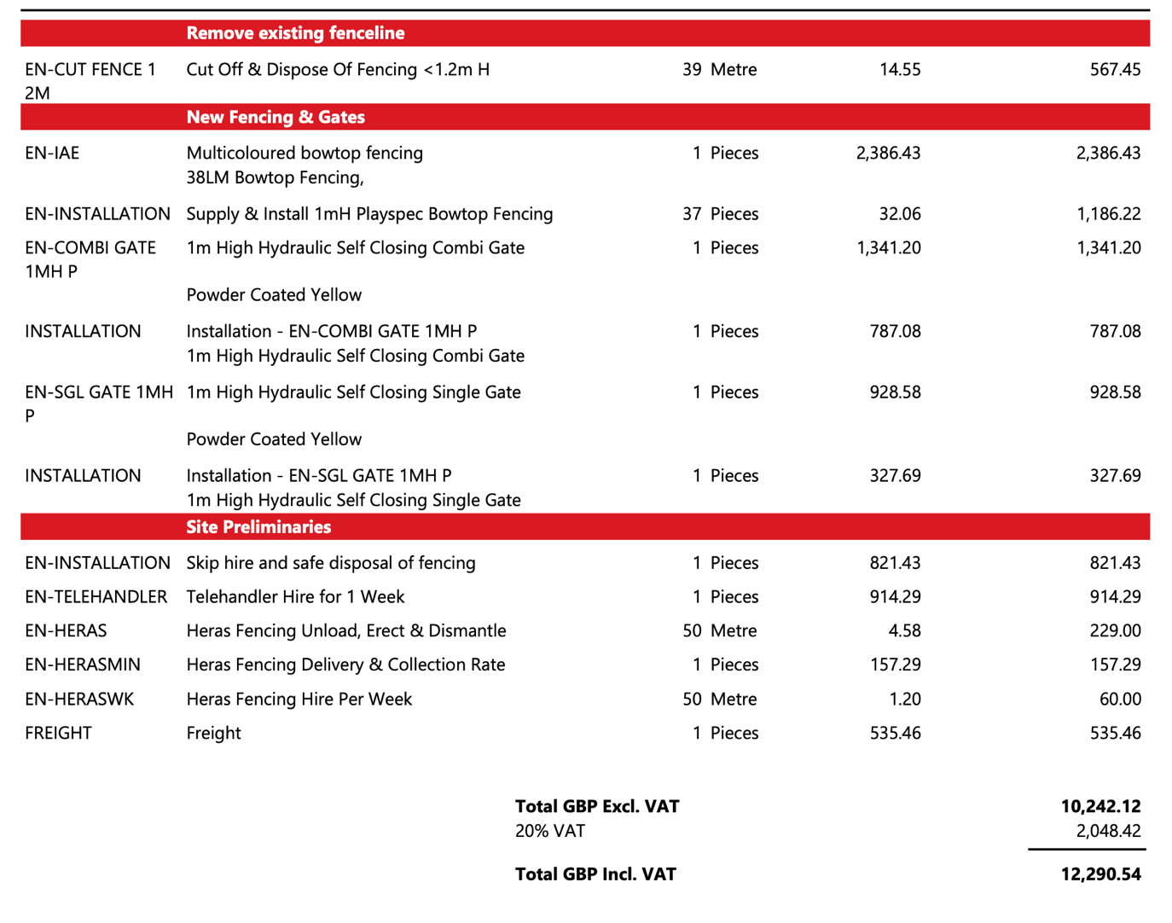
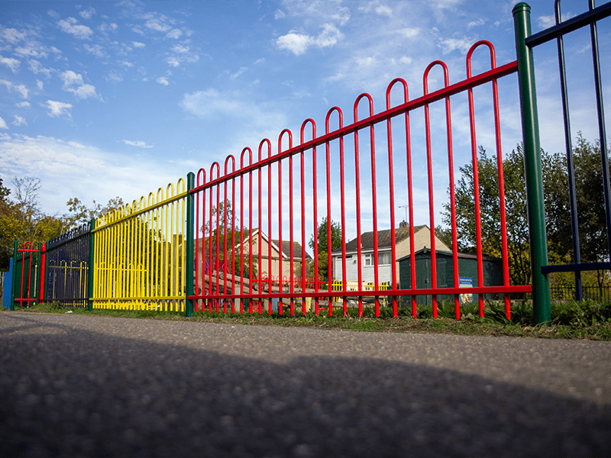

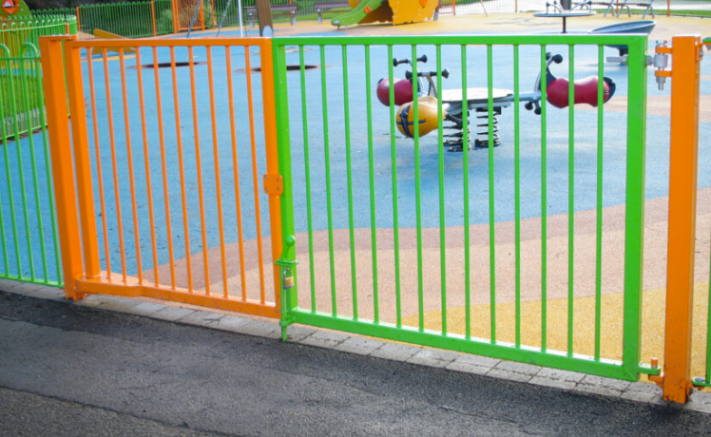

This is 2.78m wide when both sections are opened allowing vehicle access. The pedestrian access is 1.1m wide

Very rough quote – this quote had to be chased for and it is disappointing that they have not visited the site:

I have a price to share with you for the removals, install of the new Bow Top Fencing.

This price is based on 41 metres of fencing, you would be looking at around £13,595 plus VAT.

Please note all our prices are based on a site survey and as we haven't been to site this is a rough price for you.

12a – email regarding lighting issue.

Dear Donna .. I regularly visit my friend who lives at the above address. On Xmas Eve I visited at about 7pm with presents .. the whole area was in complete darkness .. whilst returning to my car I was unable to see how big the drop was from the verge/kerb to the road surface, this resulted in a heavy landing causing me to suffer compression injuries to my right knee and back .. A hospital visit confirmed soft tissue & nerve root damage in the back causing my constant pain & sciatica .. no magic remedy ... I may recover or have to manage it for the rest of my days .. not a great possible prospect, since at 75 years old I was fit and active.

An after dark visit & risk assessment at this location will confirm the unacceptable dangers both pedestrians & cyclists face at this junction with St. Matthews Close. The Memorial Hall car park light did provide some illumination in this area .. however, I understand that it has not worked for many months.

My accident has landed me with very difficult personal circumstances but sadly more serious ones are likely if the issue isn't addressed by either the Parish or Warwickshire CC Highways .. I hope so !

May I also take this opportunity to bring a plate sized footpath depression on the corner of 46 School Road to your attention .. this may be being caused by a broken drainage pipe from the adjacent manhole .. once again this is located in the darkness zone & likely to cause a fall.

I am not a resident in the Priors, just a visitor, so I leave it to your good office to take the matters further.

Your comments would be appreciated.

