Neighbourhood Governance Pack

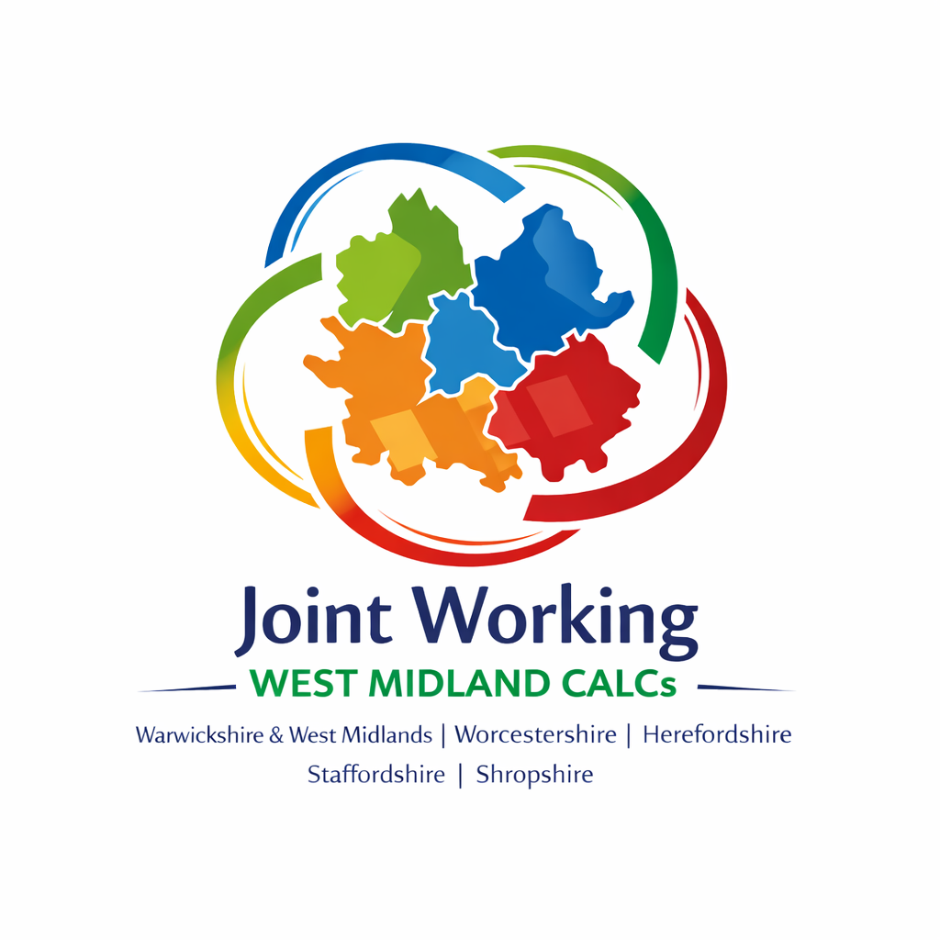

Pack contents: Council briefing, template motion and template letter to your local MP.

Overview
The UK Government’s emerging agenda on neighbourhood governance—set out through the English Devolution and Community Empowerment (EDCE) Bill—signals a shift toward more localised, community-level decision-making.
However, despite new duties placed on unitary councils, the Government has not yet provided a clear, formal definition or detailed guidance on what neighbourhood governance should look like. There is yet to be any role for parish/town councils in these new structures.

What the Government Has Said So Far
Government documents describe neighbourhood governance mainly in broad, outcome-focused terms, stating that its purpose is to “move decision-making closer to residents” and enable public services to be better organised around local needs.
The Bill gives the Secretary of State powers to define neighbourhood areas and set criteria for governance arrangements—but these definitions and criteria have not yet been issued.

Key Gap: No Clear Definition or Local Council role
Although local authority duties are being introduced, no statutory or practical definition of “neighbourhood governance” has been set out by the Government.
This leaves councils uncertain about the scale, form and minimum standards expected.

Implications for Parish and Town Councils
Neighbourhood governance reforms—driven by the English Devolution and Community Empowerment (EDCE) Bill—have significant implications for parish and town councils. While these bodies are long-established forms of neighbourhood-level democracy, the Government’s proposals introduce new expectations, uncertainty, and potential opportunities.

Parish and Town Councils Will No Longer Be the Default Neighbourhood Governance Model
The Government has stated that it “wants to make sure that all local authorities have a way of working with people in their neighbourhoods, so they are not relying on town and parish councils to do it.”

Uncertainty About Their Future Role
Because the Government has not yet defined:
- what constitutes a neighbourhood governance structure, or
- how these structures will interact with existing parish councils,
parish and town councils face uncertainty regarding:
- Their statutory position within the new framework
- Whether their existing roles will be strengthened, diluted, or duplicated

3. Potential Overlap or Duplication
With the Secretary of State empowered to define neighbourhood areas and set criteria for governance arrangements—yet without definitions currently in place—there is a risk that new, imposed neighbourhood structures may overlap with existing parished areas or the work of parish/town councils.
This could lead to:
- Confusion over responsibilities
- Blurred lines of accountability
- Challenges in community engagement

Summary
Parish and town councils are likely to remain important, but their role is no longer assumed or guaranteed.
We face a period of uncertainty while the Government develops regulations defining neighbourhood areas and governance standards. Until clarity is provided, councils must prepare for:
- Possible structural changes
- Integration with new neighbourhood models
- The need to demonstrate strong community value

Below is a ready-to-use template motion that a parish or town council can adopt. It reflects the current policy context, including the Government’s intention not to rely solely on parish and town councils for neighbourhood governance, and the lack of detailed guidance on how new structures will work alongside existing local councils.

Template Motion: Ensuring an Influential Role for Parish/Town Councils in Neighbourhood Governance
[Council Name] Parish/Town Council
Motion for Resolution
Date:
Proposed by:
Seconded by:

Motion
This Council notes:
- That the Government’s English Devolution and Community Empowerment (EDCE) Bill introduces a new duty on all local authorities to establish “effective neighbourhood governance” structures, with further detail to be set out in forthcoming regulations.
- That the Government has stated it wants all local authorities to have a way of working with neighbourhoods “so they are not relying on town and parish councils to do it,” indicating that parish and town councils may not automatically be recognised as the primary neighbourhood governance mechanism.
- That the Secretary of State will have powers to define neighbourhood areas and set criteria for neighbourhood governance arrangements, but these definitions and criteria have not yet been published, creating uncertainty about the future role of parish and town councils within the new framework. [nalc.gov.uk]
- That parish and town councils are the most local and democratically accountable tier of government, with established relationships in communities and a strong track record of facilitating local engagement and service delivery.

This Council believes:
- That parish and town councils should play a central and influential role in any new system of neighbourhood governance, reflecting their democratic mandate and deep local knowledge.
- That any new neighbourhood governance structures should complement, not duplicate or marginalise, existing parish and town councils.
- That clear guidance from Government is essential to avoid confusion, overlap, and the dilution of local democratic accountability.
- That parish and town councils are offered the opportunity to join any neighbourhood governance structures created in their area.;

This Council resolves to:
- Call on our local Member of Parliament to press the Secretary of State for Housing, Communities and Local Government to:
  - Ensure that parish and town councils are formally recognised as key partners within the emerging neighbourhood governance framework;
  - Guarantee that the forthcoming regulations and guidance clearly set out how parish and town councils will be integrated into neighbourhood governance structures;
  - Provide assurance that new neighbourhood governance arrangements will not duplicate functions or undermine the democratic legitimacy of parish and town councils.
- Write to the MP enclosing this motion and requesting active lobbying on behalf of parish and town councils during the development of regulations under the EDCE Bill.
- Engage with our principal authority to express the Council’s expectation that parish and town councils be meaningfully involved in shaping local responses to the neighbourhood governance duty.
- Publicly communicate this Council’s position to residents, reaffirming our commitment to maintaining strong, local, democratic representation.

Template Letter to your local MP
[Council Letterhead]
[Date]
[Name of MP]
Member of Parliament for [Constituency]
[Office Address]
Dear [Name of MP],
Re: Request for Advocacy on the Role of Parish/Town Councils in Neighbourhood Governance Reforms
I am writing on behalf of [Council Name] Parish/Town Council to draw your attention to significant concerns arising from the Government’s emerging neighbourhood governance proposals under the English Devolution and Community Empowerment (EDCE) Bill.
As you will know, the Bill introduces a new legal duty for all local authorities to establish “effective neighbourhood governance” structures. However, the Government has indicated that local authorities should not rely solely on parish and town councils for this purpose. Specifically, accompanying commentary to the Bill states that councils should have ways of working with neighbourhoods “so they are not relying on town and parish councils to do it.”
At the same time, the Bill provides the Secretary of State with new powers to define neighbourhood areas and set criteria for governance arrangements, but these definitions and criteria have not yet been published, leaving substantial uncertainty about how existing parish and town councils will fit within the new system.
Given that parish and town councils are the most local, democratically elected tier of government, with deep knowledge of their communities, we strongly believe they should have an influential and clearly recognised role within any new neighbourhood governance arrangements.
Enclosed with this letter is a motion passed by [Council Name] requesting that you press the Secretary of State for Housing, Communities and Local Government to:
- Ensure parish and town councils are formally recognised as key partners in neighbourhood governance.
- Provide clarity—through forthcoming regulations and guidance—on how these councils will be integrated into the new framework.
- Avoid the creation of parallel structures that could duplicate or diminish the role of democratically elected local councils.
We would be grateful for your support in raising these matters with Ministers and ensuring that community-level democratic representation is not weakened as these reforms progress.
Please do not hesitate to contact us if you would like to meet to discuss this further or require any additional information.
Yours sincerely,
[Name]
[Position, e.g., Chair/Clerk]
[Council Name] Parish/Town Council

